**Step 1 : Login console AWS :** [**https://fsoft-hcm-ctc.signin.aws.amazon.com/console**](https://fsoft-hcm-ctc.signin.aws.amazon.com/console)

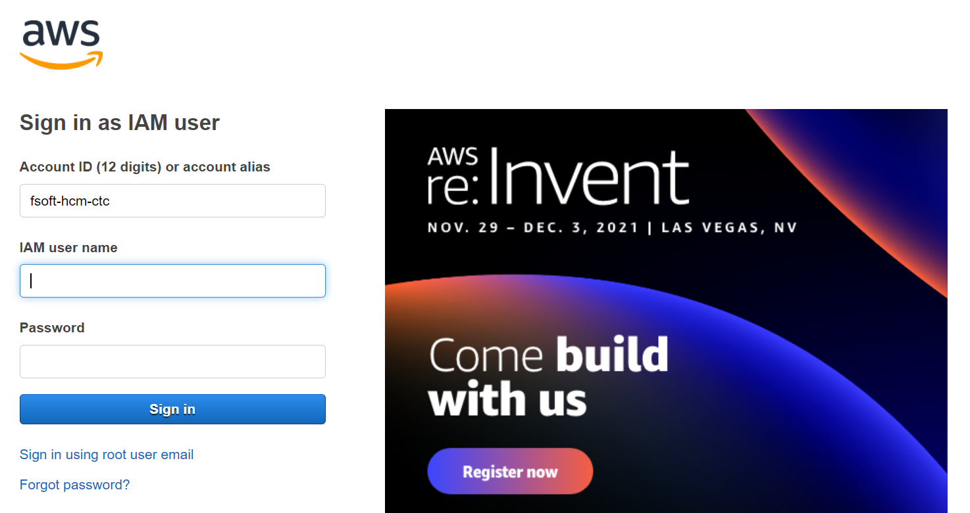

**Step 2: Change password first login**

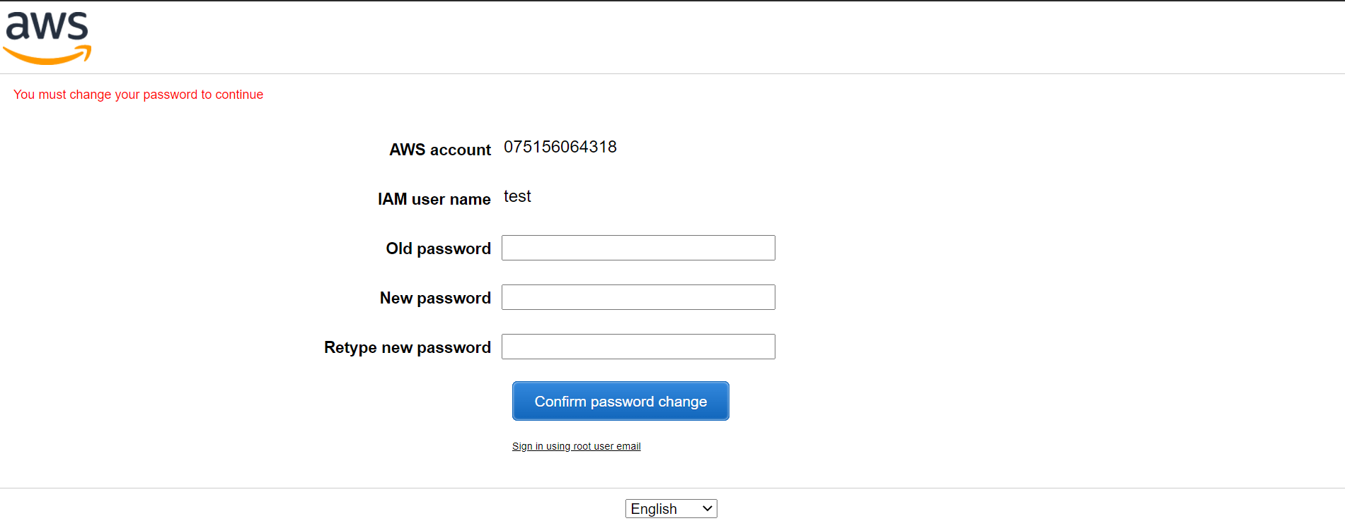

**Step 3: Login again with new password**



**Step 4 Change region to N.Virginia**

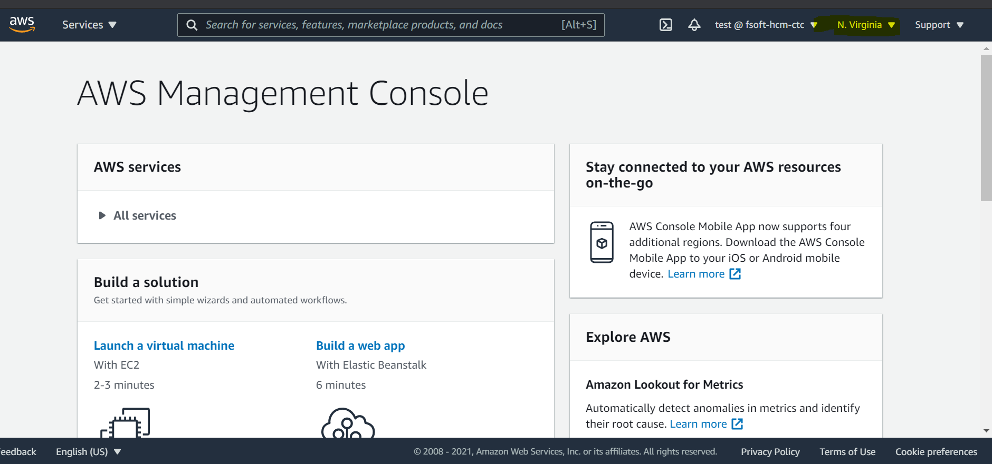

**Step 5: Used IAM service to active MFA**

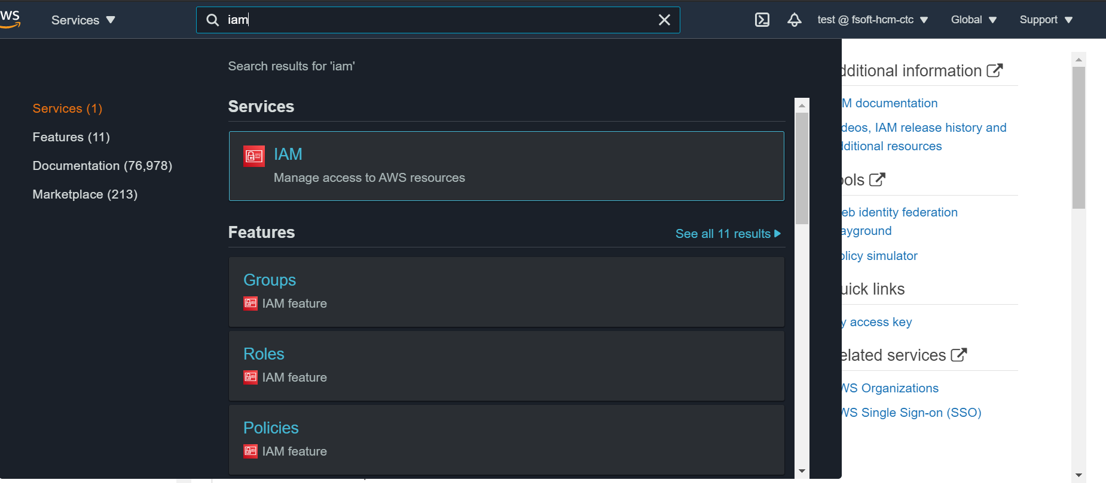

**Step 6 : Click your user , click tab Security Credentials , Choice Assigned MFA device , Click Manage** 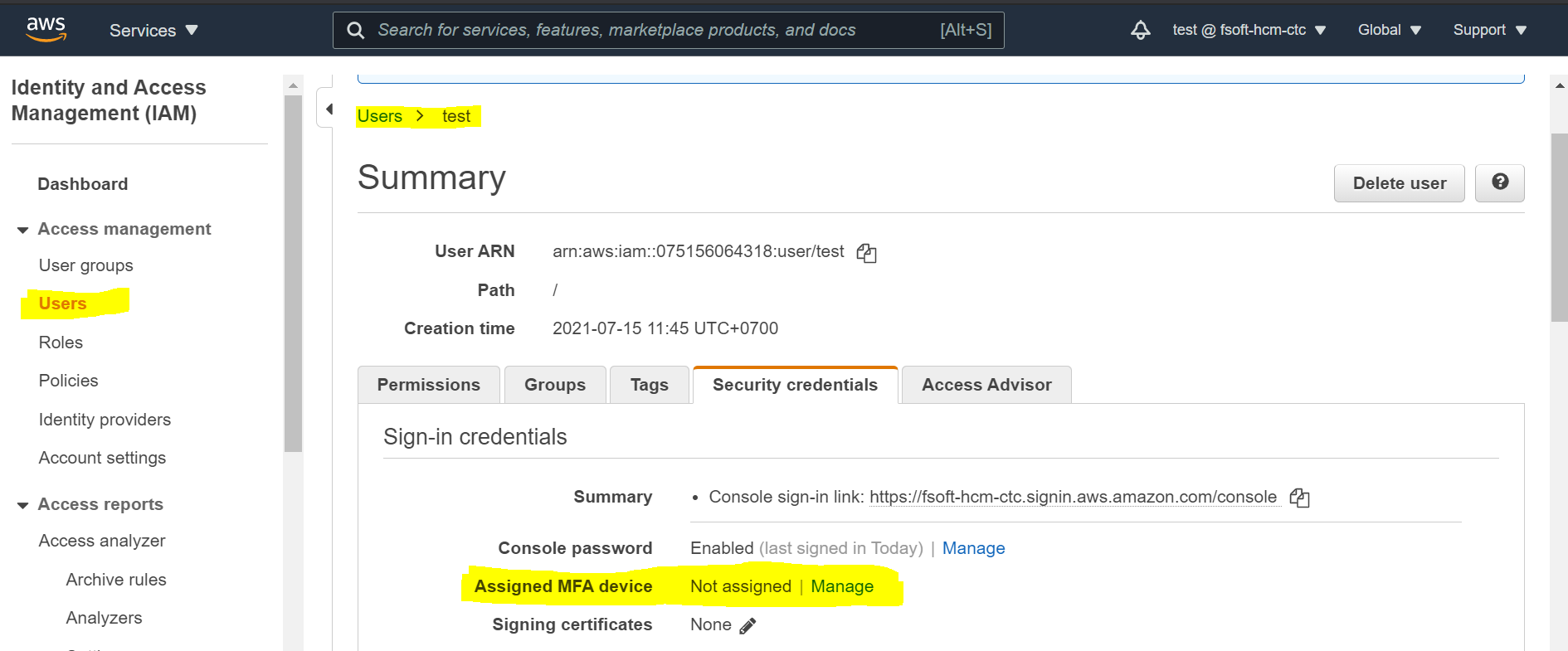

**Step 7 : Choice Virtual MFA Device , click Continue.**

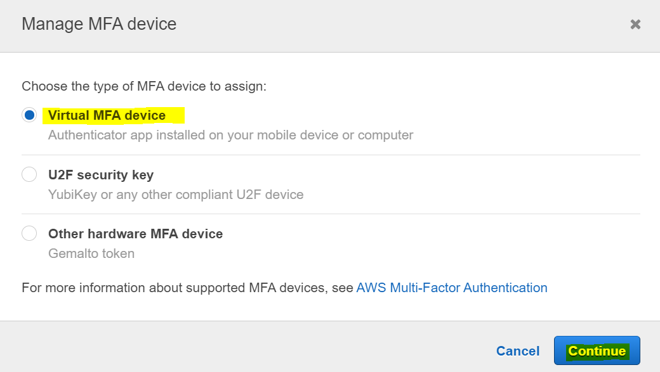

**Step 8 : Setup Virtual MFA :**

8.1. I**nstall a compatible app on your mobile device or computer**

**8.2 Use your virtual MFA app and your device's camera to scan the QR code**

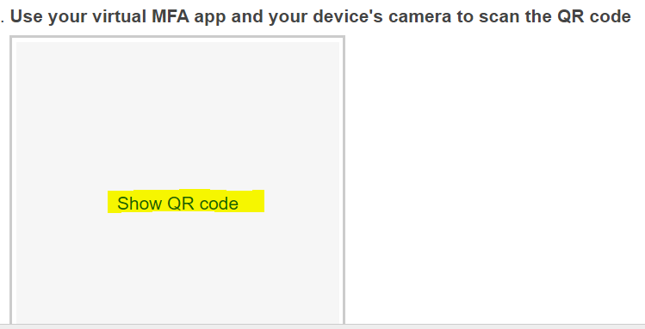

**8.3 Type 2 code and click Assign MFA**

